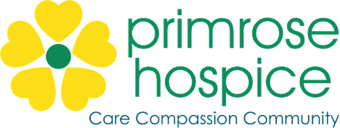

**Staff Nurse Person Specification**

**Qualifications**

|  |  |
| --- | --- |
| **Essential** | **Desirable** |
| * Registered Nurse with current NMC registration * Evidence of continued professional development * Minimum 1 year post registration experience | * Counselling qualification * Post basic qualification in palliative care or related subject |

**Skills for the role**

|  |  |
| --- | --- |
| **Essential** | **Desirable** |
| * Advanced communication skills and able to communicate effectively * Able to work effectively as an autonomous practitioner * Able to assess, plan and deliver individual care in partnership with patients / carers / other professionals * Able to undertake group health education sessions * Able to handle distressing situations with sensitivity and empathy * Enthusiasm * Motivation of self and others * Up-to-date clinical skills * Strong IT skills * Excellent verbal and written communication skills * Strong time management skills * Understanding and support of the benefits of clinical supervision and reflective practice * Able to work across the multidisciplinary health and social care team | * Interest in working with volunteers * Breaking bad news experience * Venepuncture and/or cannulation skills (training will be given) * Up to date knowledge of current palliative care issues |

**Experience/Knowledge for the role**

|  |  |
| --- | --- |
| **Essential** | **Desirable** |
| * Experience of working within the field of palliative care / caring for palliative care patients * Working with a team * Clinical audit | * Community experience * Palliative care /Oncology experience |